**Big Data Analytics and Application**

**Identifying pests and weeds in farm**

**Team-16**

**Narendranadh perni-18212880**

**Durga Krishna deep arumilli-16322737**

**Praneeth Chowdary Uppalapati-16323350**

**Susmitha Veeravalli-16323333**

**Introduction**

The expected world population is projected to be over 9 billion by the 30 years. There is a growing challenge of trying to feed all this people due to the emerging challenge of scarcity of new arable land. There is also the challenge of global warming which has caused climate change and the societal demand for decreasing the environmental impact of agriculture. Weed management, pest management and water management will be of great importance in maximizing yields. Weed and pest cause crop yield losses of 32% and 18% respectively.

Big data has become the heart of all industries in the world we live in today. It has quickly become an important tool in decision making. The information gathered from the big data can potentially transform the future of most sectors if not all. Agriculture depends on data to function efficiently. You must have the data of the amount of rainfall, type of soil, weather and climate etc. big data’s role in agriculture can be of great importance if used in proper manner. There are already a variety of ways that big data is driving the future of agriculture in developed countries. Big data comprises of modern systems like database systems, machine learning statistics, deep learning and artificial intelligence.

There are already other technologies that farmers are using now to increase yields. There are three technologies in existent today:

1. FMIS (farm management information system

This is an information system that deals with the planning, collection, processing, storage and dissemination of data to aid in farm operations.

1. Precision Agriculture

This can be defined as the scientific domain that deals with the management of temporal and spatial variability to maximize profits and decrease environmental impacts.

1. Artificial intelligence and Big Data.

This is the process of applying artificial intelligence methods at all levels of farming. This also includes the use of robots to detect anomalies in the farm. Human activities have led to climate change which is among the biggest threats to agriculture.

How application of big data has helped the agriculture industry

Unpredictable weather patterns which have caused global food shortages has exerted pressure on use of big data. big data has helped farmers come up with informed decisions on agriculture by eliminating all variables and uncertainties in the future.

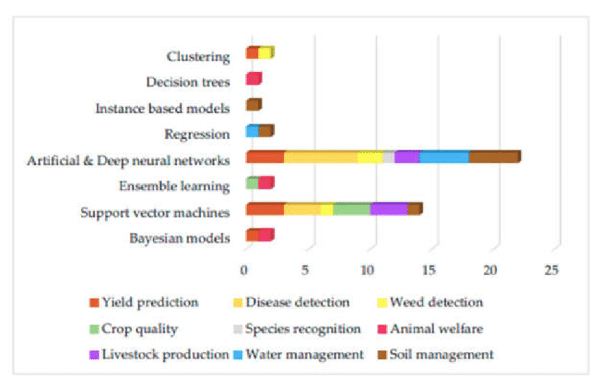

Application of machine learning and big data in agriculture

Big data is transforming agriculture in the following ways:

1. environment tackling

agriculture and the environment go hand in hand. Farmers depend on the environment and weather patterns of their regions. Due to the increased threat of global warming, farmers are finding it hard to deal with the variables associated with agriculture today. This is where big data shows its potential power by utilizing various analytical tools that allow farmers to monitor environment conditions.

1. improving efficiency and encouraging innovation

efficiency is vital in the success of agriculture. Big data helps maximize efficiencies by storing important data points and providing important cues.

1. reducing costs

big data helps in tackling the environment and improving efficiency. This in turn has a direct and extensive impact on the expenses incurred by the farmers.

1. supply chain management
2. Using pesticides ethically

Administration of pesticides has been an antagonistic issue because of its secondary effects on the biological system. Enormous information permits ranchers to deal with this better by prescribing what pesticides to apply, when, and by how much. By observing it intently, farmers can cling to unofficial laws and keep away from abuse of synthetics in food creation. Besides, this prompt expanded productivity since crops don't get annihilated by weeds and bugs.

1. Optimizing farm equipment

Sensors have been embedded into agricultural machinery by companies like John Deere, and big data technologies have been deployed to enable fleet managers effectively manage their fleet. This kind of management can be lifesaving for big farms, as it informs users of tractor availability, maintenance due dates, and fuel refill warnings. In essence, this streamlines agricultural equipment usage while also ensuring its long-term health.

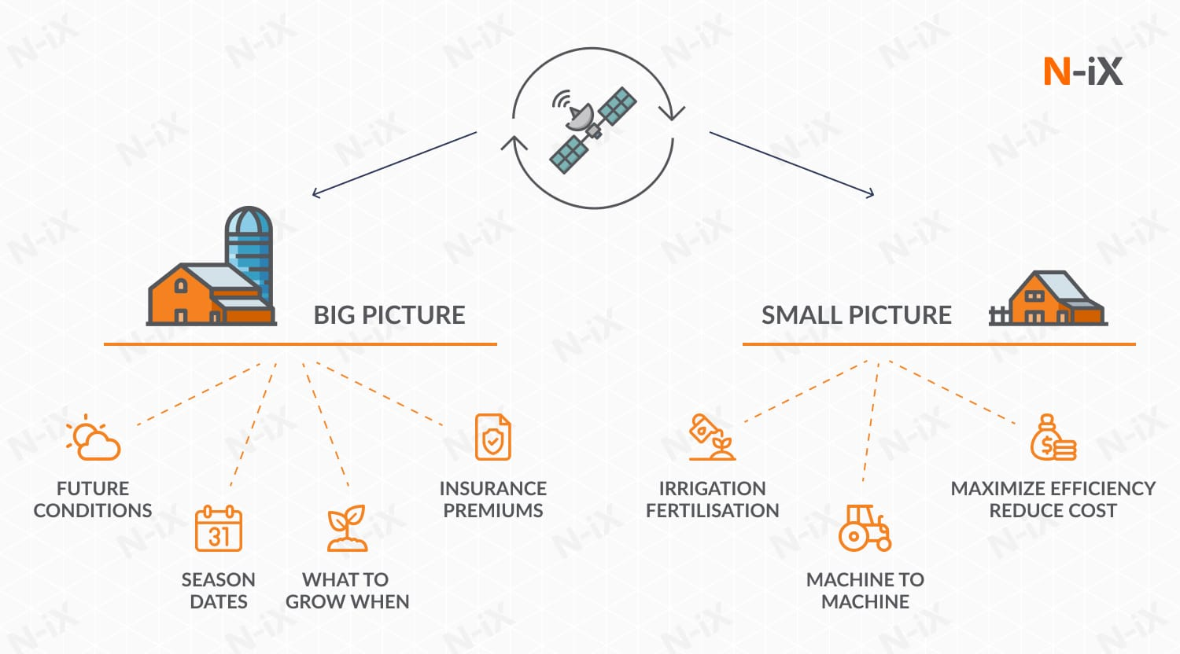

An overview of how big data is applied in agriculture

**Objectives**

The main objective of big data on farming is to improve the operational efficiencies of farmers and building an image recognition model to identify and classify different types of weed and pest and methods to get rid of them.

Agriculture is a source of income for many people in the world today. For farmers who practice large scale or small-scale farming both experience the same problem. The main challenges that are there in agriculture are weed, pest and water. These challenges affect the outcome of the yield. Farmers have been relying on traditional methods to try to maximize yields. A lot of farmers are not familiar with the different types of pests and weed that are there. Most of the small-scale farmers cannot afford to hire agricultural experts to seek the pest and weed mess.

**Characters or people in the main story (end users of the application)?**

The main characters involved in this type of project are the farmers, university students, agricultural experts and researchers. However, it’s not only farmers that use big data solution for weed and pest control. In some of the countries in Europe, there has been an increase in the number of invasive alien species (IAS). These countries have applied the use of big data to flash and prevent superfluous spread of IAS. Big data has also been used by these European countries as a prediction tool to know which areas may be affected by IAS. Locations that were vulnerable to IAS were recognized using species circulation data, local environment data in conjunction with species distribution models.

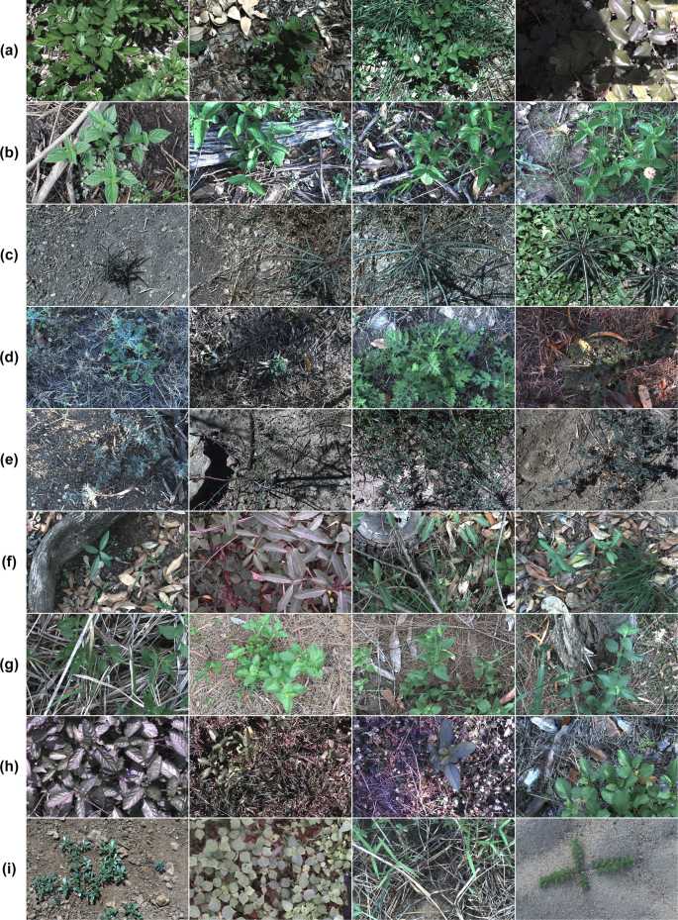

A variety of some of the weed found globally

**What are the current solutions to the problem that you want to solve** (Your competitors)?

The current solutions are like our solution but do not cover other areas other than the areas they were meant to cover. All current technologies also do not make use of the cloud to make this data accessible to majority of people.

**Why your solution is better than the one described in the previous question?**

Our solution will make good use of the cloud for agriculture. Big data in farming can be used by a lot of farmers. All these farmers have to access this data and use it for their own farms. The cloud is a good place for all this data to be stored and be accessed by millions of farmers all over the world. Most big data technologies that are there today focus only on their area of jurisdiction. Achievement in farming has been in large part dependent on favorable natural forces, but not anymore. The approaching together of cloud computing and big records has ensured that farmers have enough records factors to make right selections. Cloud computing has democratized the availability of large computing strength as statistics facilities and storage are actually to be had on a ‘pay-as-you-move’ version. This has made it feasible to bring together know-how repositories that include facts inclusive of climate, irrigation practices, plant nutrient necessities, and numerous different farming techniques.

Cloud-based totally apps can manual farmers on the way to alter their production based on marketplace demand and the way to enhance their yield and profitability. nowadays, a farmer can micromanage farming and all its accompanying sports — even earlier than planting crops, it’s possible to estimate the outcomes via tweaking the variables involved.

**Conclusion and recommendation**

The application of big data in agriculture has shown much potential in tackling the global hunger crisis. Market forecaster have projected that data driven farming is estimated to rise from $585 million in 2018 to $1.4 billion in 2025. This is an increase of over 120% which has been fueled by the application of big data in agriculture. As data-driven agriculture matures, more and more farmers will embrace big data technologies.

For long, we have been relying on our instincts and our estimates to make decisions. Human beings are intelligent but have never had the gift of precision, and this where big data comes in handy to maximize yield in agriculture. Farmers can now eliminate discrepancies and stay steps ahead of their ecosystem. Big data will ensure that in years to come agriculture will remain a stable and feasible line of work.

**Executable Code**

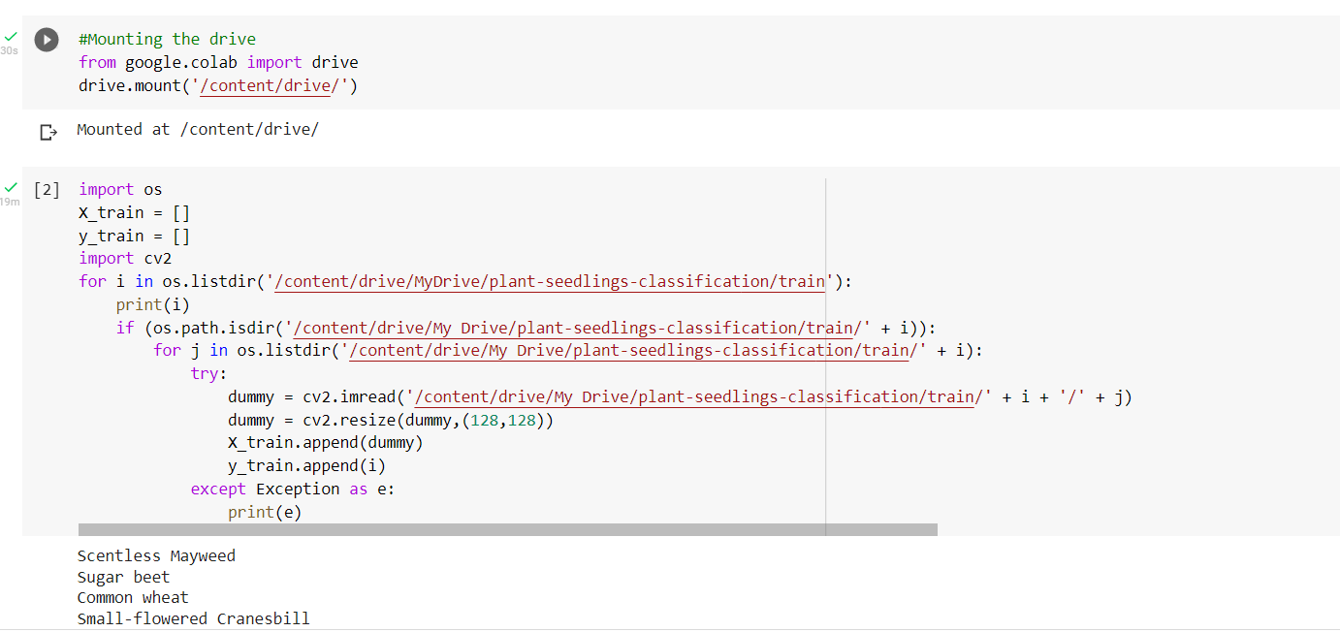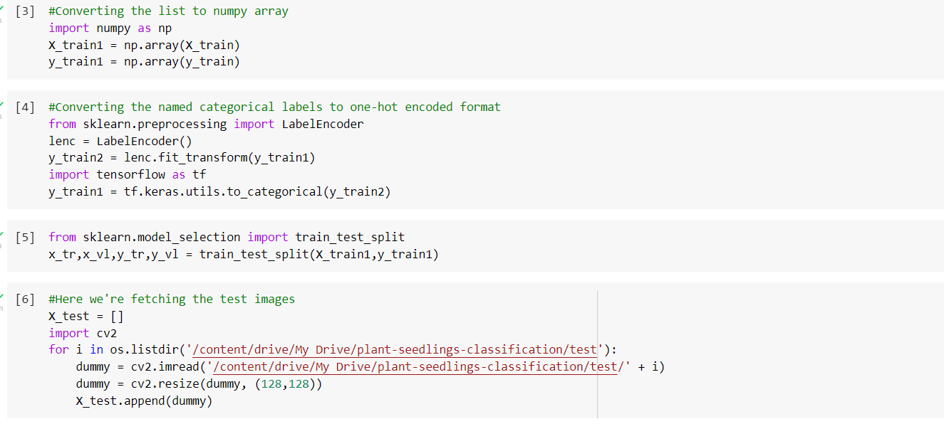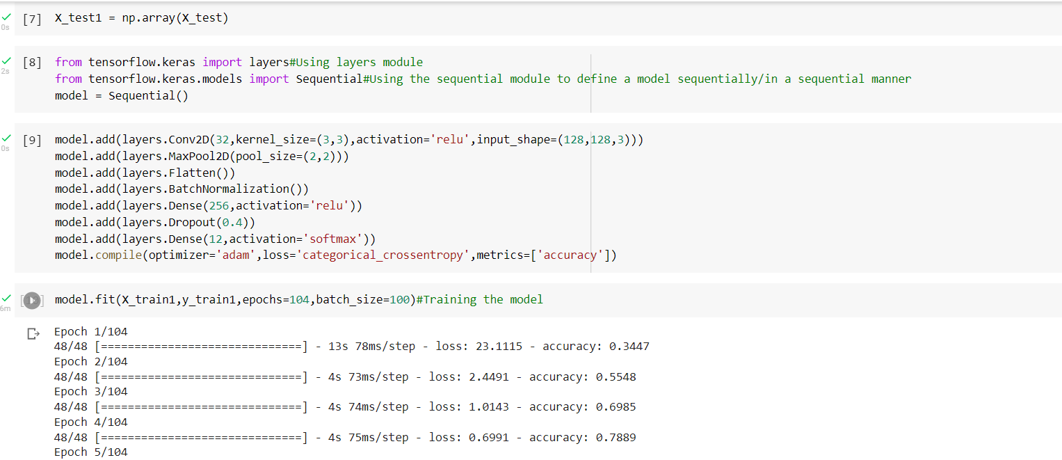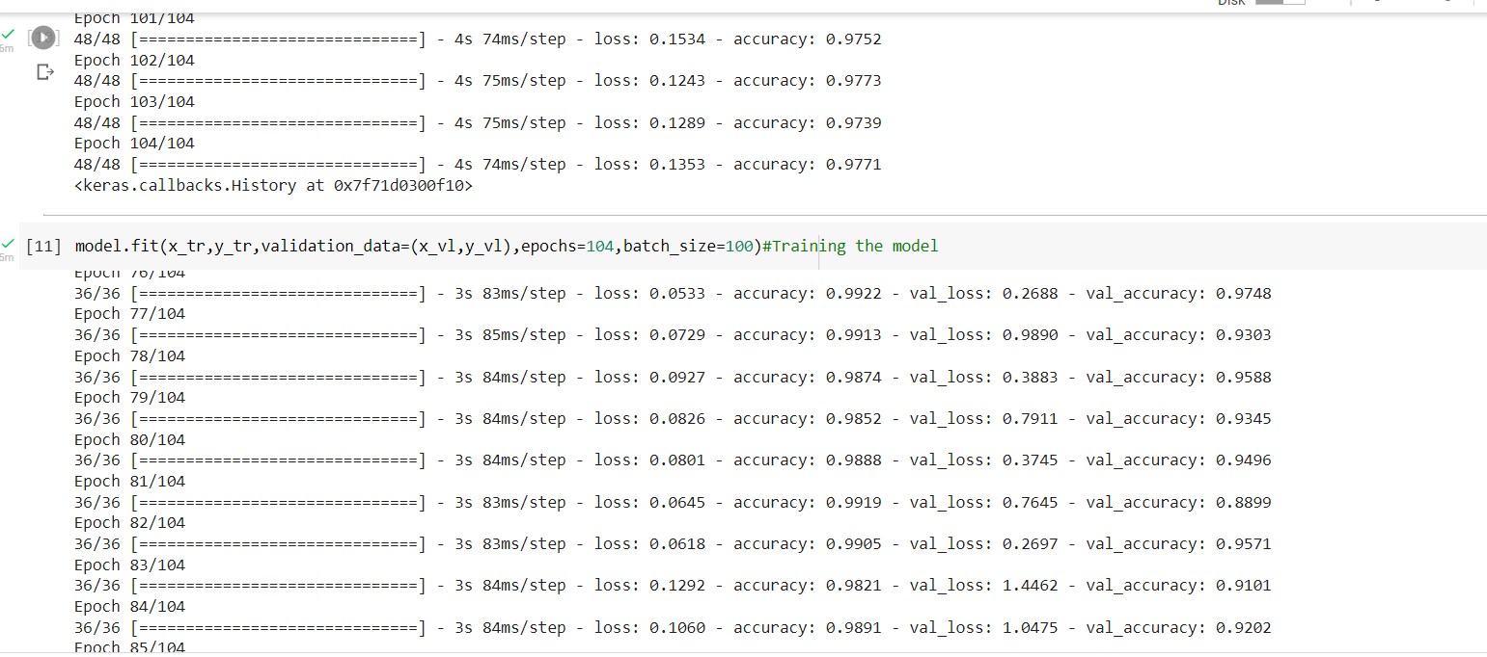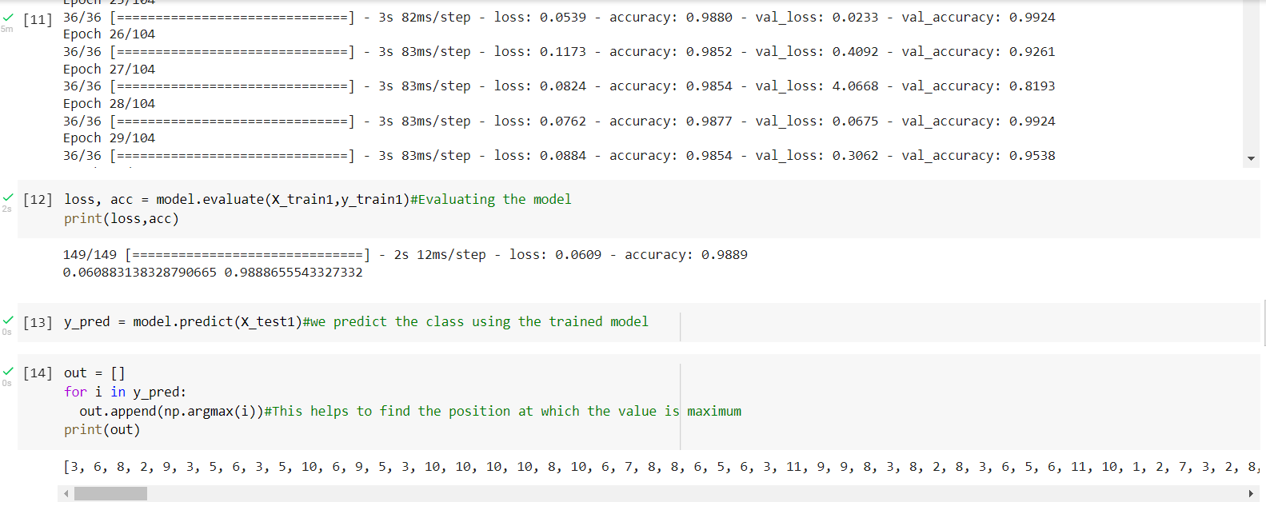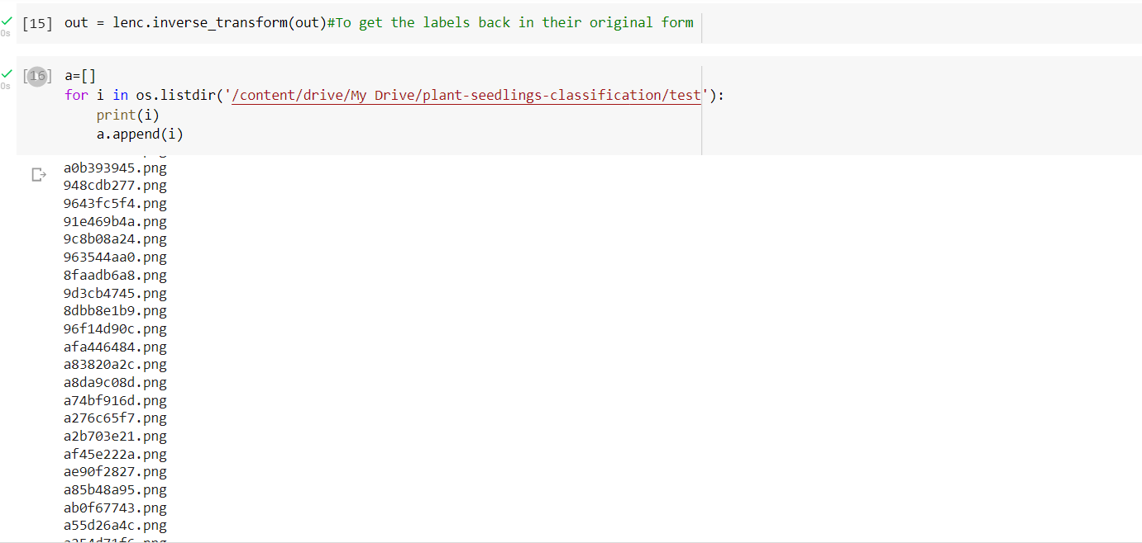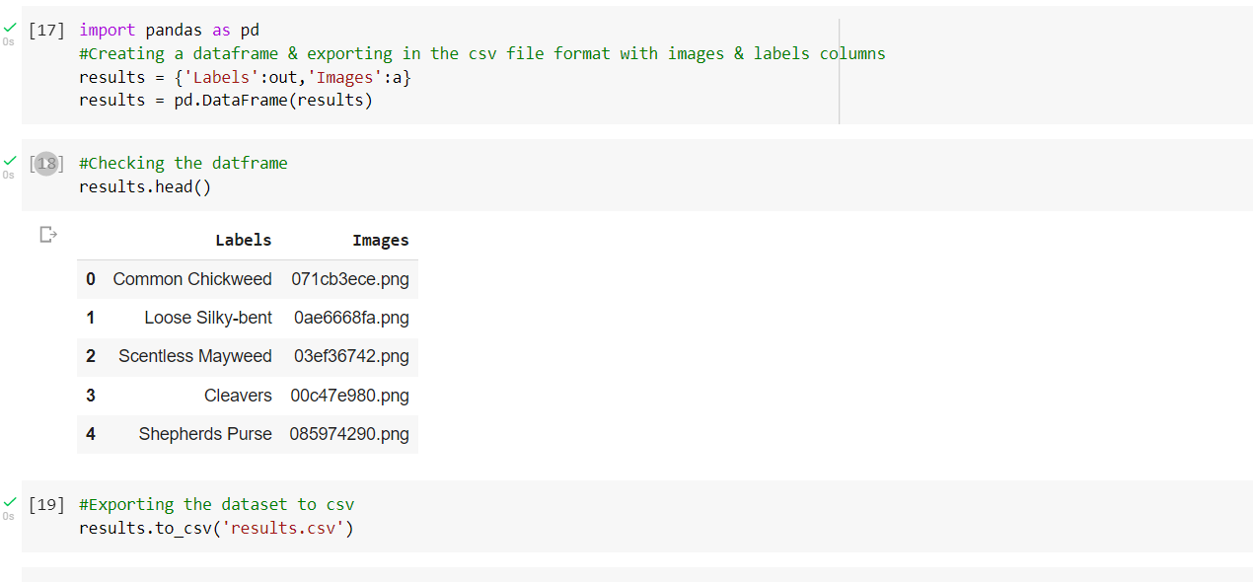

**Reference**

Fernández-Quintanilla, C. et al. Is the current state of the art of weed monitoring suitable for site-specific weed management in arable crops? Weed Res. 58, 259–272 (2018).

Gonzalez-de Santos, P. et al. Fleets of robots for environmentally safe pest control in agriculture. Precis. Agric. 18, 574–614 (2017).

Slaughter, D. C., Giles, D. K. & Downey, D. Autonomous robotic weed control systems: A review. Compute. Electron. Agric. 61, 63–78 (2008).

Shaner, D. L. & Beckie, H. J. The future for weed control and technology. Pest Manage. Sci. 70, 1329–1339 (2014).